**For linux machine**

1. Download Site24*7 agent.

**sudowget**[**https://plus.site24x7.com//sagent//Site24x7_Linux_64bit.install**](https://plus.site24x7.com//sagent//Site24x7_Linux_64bit.install)

sudowgethttps://www.site24x7.com/help/admin/adding-a-monitor/linux-server-monitoring.html#install-linux-agent

2. Change the permission

**Sudo chmod 755 Site24x7_Linux_64bit.install**

1. Install the agent
2. **sudo ./Site24x7_Linux_64bit.install -i -key=us_98a82f74b0627ccfed4d8a7a01c9a02c56a6c6d2**

**sudo ./Site24x7_Linux_64bit.install -i -key=us_98a82f74b0627ccfed4d8a7a01c9a02c56a6c6d2**

Where key = 823f8d80087f9233c6278b7c71d5885415a30bcf

*bash -c "$(curl -sL https://staticdownloads.site24x7.com/server/Site24x7InstallScript.sh)" readlink -i -key=***us_98a82f74b0627ccfed4d8a7a01c9a02c56a6c6d2** *-dn=test_server -gn=aws -tp=profile1 -np=profile2*

---To get the key go the site 24*7

---Go to admin

---then go to Developers

---then go to Device Key

---- copy the key

Key location -

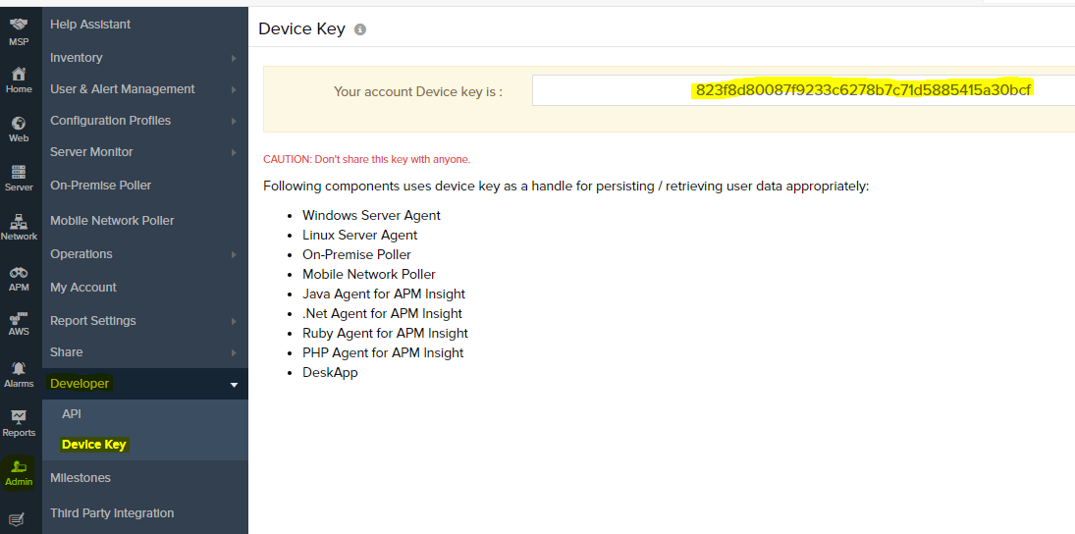

823f8d80087f9233c6278b7c71d5885415a30bcf

sudo /etc/init.d/site24x7monagent restart

sudochkconfig site24x7monagent on

For uninstall

sudo /opt/site24x7/monagent/bin/uninstall

/etc/init.d/site24x7monagent

bash -c "$(curl -sL [https://staticdownloads.site24x7.com/server/Site24x7InstallScript.sh](https://www.google.com/url?q=https://staticdownloads.site24x7.com/server/Site24x7InstallScript.sh&sa=D&source=hangouts&ust=1528802896490000&usg=AFQjCNES62t7JHZxe3VYb3aIzCGFwBsswg))" readlink -i -key= us_e376e715284512427e513c1937fff0c3d245dea8 -dn=test_server -gn=aws -tp=profile1 -np=profile2